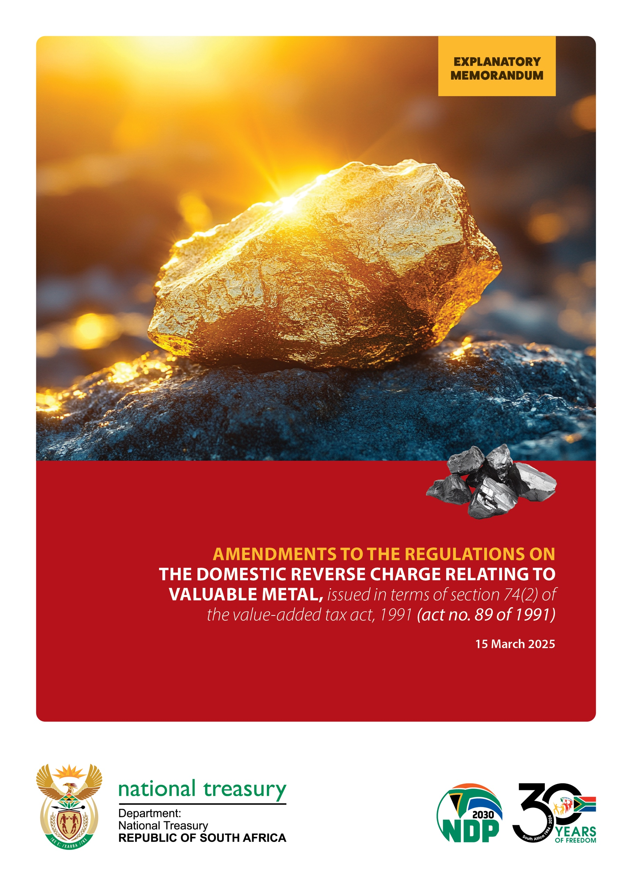

Table of Contents

1. BACKGROUND 1

2. REASONS FOR CHANGE 1

3. PROPOSAL 1

4. EFFECTIVE DATE 2

1. BACKGROUND

Prior to 2014, a deduction of notional input tax on the acquisition of gold jewellery by registered VAT vendors from non-VAT vendors was allowed. This provision created an opportunity for VAT vendors to claim fraudulent input tax deductions. In 2014, Government responded by making changes to the definition of “*second-hand goods*” in section 1(1) the Value-Added Tax Act, 1991 (Act No. 89 of 1991) (“the VAT Act”) to the effect that vendors were excluded from claiming notional input tax on second-hand goods containing gold, unless such goods were re-sold in the same or substantially the same state as they were bought in.

Despite the amendment to the definition of “*second-hand goods*” in section 1(1) of the VAT Act, vendors used a new *modus operandi* to extract undue VAT refunds from the *fiscus* and moved away from making fictitious input tax deductions under the pretence that the goods are second-hand goods, containing gold. These vendors registered businesses as vendors for VAT purposes and fabricated the documentation required for input tax purposes (invoice farms). These vendors acquired Krugerrands, illegal gold, *etc.* and introduced them in the production and distribution chain to manufacture mainly goods containing gold in the form of jewellery, bars, blank coins, ingots, buttons, wire, plate, granules, in a solution, residue or similar forms, for export purposes.

In order to curb these VAT fraud schemes, Government introduced the Domestic Reverse Charge Regulations[1] (“DRC Regulations”) in terms of section 74(2) of the VAT Act to foreclose schemes and malpractices to claim undue VAT refunds from SARS by vendors operating in the value chain relating to high-risk goods containing gold. The policy objective of the DRC Regulations is an anti-abuse measure aimed at curbing the VAT fraud scheme, specifically aimed at goods in the form of jewellery, bars, blank coins, ingots, buttons, wire, plate, sponge, powder, granules, in a solution, sheet, tube, strip, rod, reside or similar forms, containing gold, including any ancillary goods or services.

In May 2024, government introduced further amendments to the regulations to curb further abuse, as some taxpayers in this space became more creative in their anti-avoidance schemes.

1. REASONS FOR CHANGE

It has now come to Government’s attention that the exclusion in paragraph (a) to the definition of “valuable metal” in regulation 1 has led to the schemes and malpractices being shifted to the primary gold sector.

1. PROPOSAL

It is proposed that the exclusion contained in paragraph (a) to the definition of “valuable metal” in regulation 1 be deleted.

1. EFFECTIVE DATE

The amendments to the DRC Regulations come into effect on 1 April 2025.

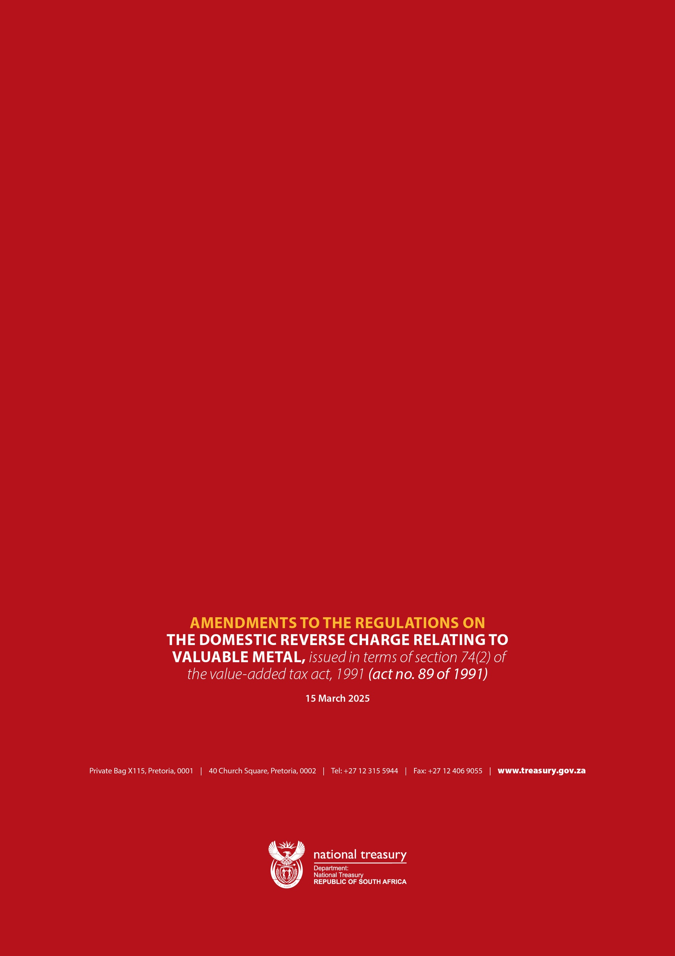

1. Published in Government Notice 2140 of 8 June 2022.